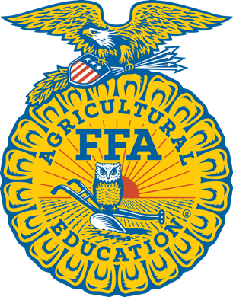
FOR IMMEDIATE RELEASE: CONTACT: Teacher Name
WEEKDAY, Month Day, Year OFFICE: (555) 555- 5555

CHAPTER NAME INTERACTS WITH LEGISLATORS IN NASHVILLE

NASHVILLE, TN – The Chapter Name Chapter of Town, Tennessee travelled to Nashville to attend the Tennessee FFA Legislative Breakfast, hosted by the Tennessee FFA Foundation and sponsored by AT&T Tennessee and members of the Tennessee Bankers Association. During this event, FFA members and their advisors were able to share a meal with senators and representatives at the Musicians Hall of Fame and Museum, just a few blocks from the Tennessee State Capitol. This year’s program included state leaders such as Governor Bill Lee and Lieutenant Governor Randy McNally, and Speaker of the House of Representatives Cameron Sexton.

The Tennessee FFA Legislative Breakfast is one of thousands of events celebrating National FFA Week, a time to share what FFA is and the impact it has on members every day. It is also a time to advocate for agricultural education, as many FFA chapters coordinate legislative visits and deliver student-created floral arrangements to legislators following the breakfast.
FFA makes a positive difference in the lives of students by developing their potential for premier leadership, personal growth, and career success through agricultural education. Nationally, there are 850,823 FFA members, aged 12-21. The Tennessee FFA Association is comprised of more than 30,000 members from 235 chapters across the state. To learn more about FFA, visit www.tnffa.org.
Insert Photo of students at Legislative Breakfast

(Photo Caption: Pictured Left to Right- Names.)

###

School Address

