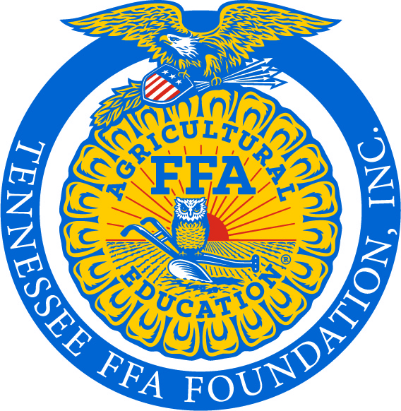

FOR IMMEDIATE RELEASE: CONTACT: Mrs. Kelsey Rose
Thursday, December 6, 2018 OFFICE: (931) 372-6029

HUMPHREYS FARMERS CO-OP GIVES $7,900 TO LOCAL FFA PROGRAMS

CENTERVILLE, TN – Humphreys Farmers Co-op recently awarded $1,580 to 5 local Future Farmers of America (FFA) chapters. The money, totaling $7,900, was given in partnership with lending cooperative CoBank as part of its Sharing Success program.

Under “Sharing Success,” CoBank will match contributions by its cooperative customers to the nonprofit organizations of their choice on a dollar-for-dollar basis, from a minimum of $1,000 up to a maximum of $5,000. Since the program’s inception in 2012, Humphreys Farmers Co-op and CoBank have jointly given more than $50,000 to area FFA chapters.

Chapters that received funds include: East Hickman FFA, Hickman County FFA, Houston County FFA, McEwen FFA, and Waverly FFA.

East Hickman chapter advisor, David Flowers, said the donation is always a huge help to their chapter and that funds will be used to help with various chapter functions.

FFA members representing each of the Hickman County chapters visited the Centerville Humphreys Farmers Co-op location to receive the check from Branch Manager, James Mathis. General Manager, Randy Hite, said “The Co-op Board and Management feel that supporting the future leaders of agriculture is very important. Using the CoBank Sharing Success is a way to give more to the FFA & 4-H.” Randy was an FFA member at Montgomery Central High School in Cunningham, TN.

FFA makes a positive difference in the lives of students by developing their potential for premier leadership, personal growth and career success through agricultural education. Nationally, there are 669,989 FFA members, ages 12-21. The Tennessee FFA Association is comprised of more than 13,000 members from 211 high school chapters, 7 middle school chapters and 8 collegiate chapters across the state of Tennessee. To learn more about FFA visit www.tnffa.org.

(Photo caption: Pictured left to right - Hickman County FFA Chapter member Will Jenkins, President Ashlee Williams and Bella Samples; Humphreys Farmers Co-op Centerville Branch Manager James Mathis; and East Hickman FFA Chapter Reporter Alaina Frazier and Treasurer Ethan Wilson.)

###

